**Grove - Air Quality Sensor v1.3**

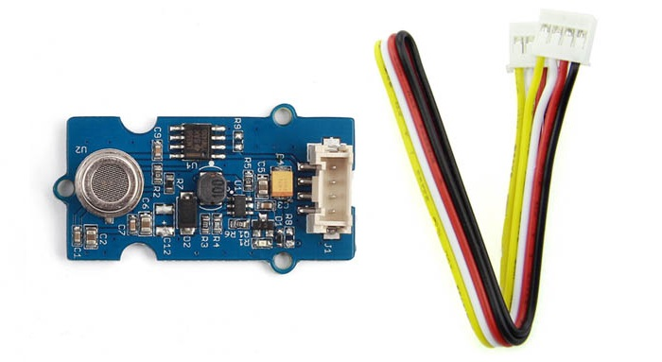

This sensor is designed for comprehensive monitor over indoor air condition. It’s responsive to a wide scope of harmful gases, as **carbon monoxide**, alcohol, acetone, thinner, formaldehyde.

## **Features**

* Responsive to a wide scope of target gases
* Cost efficient
* Durable
* Compatible with 5V and 3.3V

## **SPECIFICATION**

* Sensor: Winsen MP503
* Power:  5V or 3.3V
* Dimension: 40x20mm

**Requirements: -**Raspberry Pi, Grove air quality sensor v1.3, GrovePi+

**Raspberry Pi**

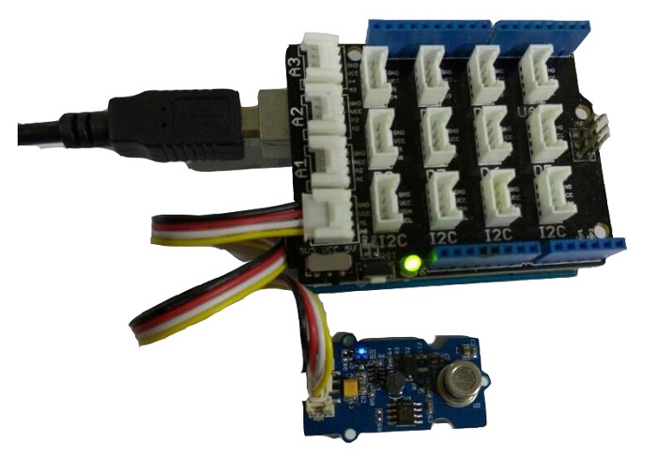

1. We need to prepare a raspberry pi and a grovepi or grovepi+.

2. We need to complete configuring the development environment.

3.Connection - Plug the sensor to grovepi socket A0 by using a grove cable.

4.Navigate to the demos’ directory:

cd yourpath/GrovePi/Software/Python/

To see the code

nano grove_air_quality_sensor.**py** # "Ctrl+x"**toexit** #

**import** time

**import** grovepi

*# Connect the Grove Air Quality Sensor to analog port A0*

*# SIG,NC,VCC,GND*

air_sensor = 0

grovepi.pinMode(air_sensor,"INPUT")

**whileTrue**:

**try**:

*# Get sensor value*

sensor_value = grovepi.analogRead(air_sensor)

**if**sensor_value>700:

**print**"High pollution"

**elif**sensor_value>300:

**print**"Low pollution"

**else**:

**print**"Air fresh"

**print**"sensor_value =", sensor_value

time.sleep(.5)

**except**IOError:

**print**"Error"

5.Run the demo.

sudo**python** grove_air_quality_sensor.**py**

**Open serial monitor**

**Output:-**

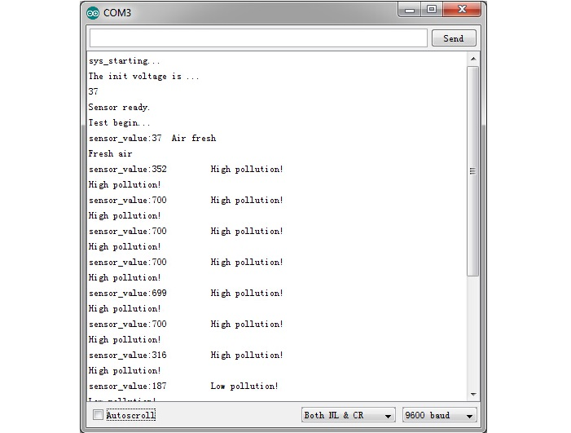

**WEBSITE:-**

http://wiki.seeed.cc/Grove-Air_Quality_Sensor_v1.3